**Mid Report**

**On**

**Doctor Appointment Management System**

**By**

**YogeshChandwani (171500402)**

**Saurabh Kumar (171500301)**

**Sumit Singh (171500347)**

Under the Supervision of

**Ms. Ruchi**

**(Technical Trainer)**



Department of Computer Engineering and Applications

**GLA UNIVERSITY**

**Mathura**

**Abstract**

This report contains the detailed information about each and every single process, during the development of **“Doctor Appointment System**” till now. In this report all the types of development procedures are mentioned. This project based on the **Mean Stack** which is a high-level Web framework that encourages rapid development and clean, pragmatic design. Built by experienced developers, it takes care of much of the hassle of Web development, so you can focus on writing your app without needing to reinvent the wheel. It’s free and open source.This report also contain the information about what is the status of our project , how much is completed and how much is left. All implementations details are also in this report.

**Contents**

1.Introduction

1.1 General Introduction to the topic

1.2 Area of Computer Science

1.3 Hardware and Software requirements

2. Problem Defintion

3. Objectives

4. Methodology

5. Implementation Details

6. Contribution Summary

7. Progress till date & the Remaining work.

8. Refrences

**1.Introduction**

**1.1 General Introduction of Project :**

The project Doctor Appointment System is to provides patients or any customer an easy way of booking a doctor’s appointment. This system overcomes the issue of managing and booking appointments according to customer’s choice or requirements. In this project customers can view many booking slots available and select the preferred date and time. The already booked space will be marked red and will not be available for anyone else for the specified time. This system also allows users to cancel their booking. This system also allow patients as well as doctors to update their details anytime.

The Administrator can add doctors and can see all appointments. Admin have a authority of to remove patients as well as doctors from their database.

**1.2 Area of Computer Science :**

This project mainly covers the Area of Web Development of Computer Science. Through this project, we are trying to climb one step in this vast field of Computer Science. It is totally of web development project. **Web development** is the work involved in developing a web site for the Internet or an intranet (a private network) Web development can range from developing a simple single static page of plain text to complex web-based internet application. We are trying this kind of thing.

**1.3 Hardware and Software Requirements :**

**Hardware Requirements :**

1. A PC minimum of 2GB RAM
2. Some part of memory to store data.

**Software Requirements :**

1. One Text editor (VCS, Sublime, Brackets etc.)
2. Node.js
3. MongoDB
4. Angular/CLI (Installed via command)

**2.Problem Statement :**

The Major Problem in the Medical department is to book an appointment.The situation when patient comes to the clinic they need to wait for a long period of time for their treatment and they also needs to come to the clinic specifically to book an appointment.This problem will become a apportunity for our group to build a website that will solve these medical department problems.Online Doctor Appointment system is a system that focusing on online appointment application and in this system patient is allowed to book an appointment from his home based on the availability of doctors.

**3.Objective :**

* with this appointment system patient can easily book their respective doctors by just a few clicks.
* To facilitate the patient with the real time healthcare scheduling.
* To optimize time saving.
* To ensure easier,reliable and faster appointment service.
* Show information and description of the doctor.
* Reduce manual work for appointment.
* Providing search facilities based on hospitals and doctors.
* Alert message for patient when the appointment get fixed.
* To give clinic staffs an easy way in doing information maintenance and updates

**Methodology**

DATA FLOW CHART OF PROJECT

**Implementation Details**

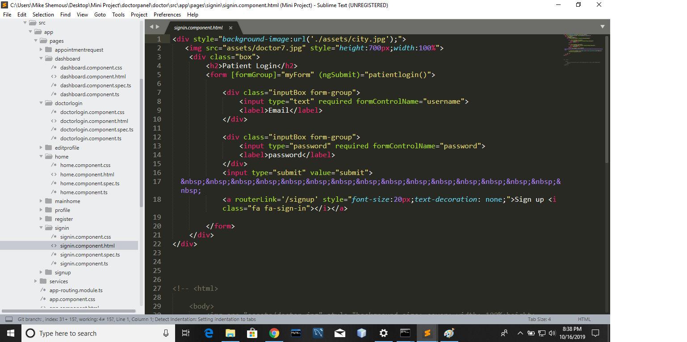

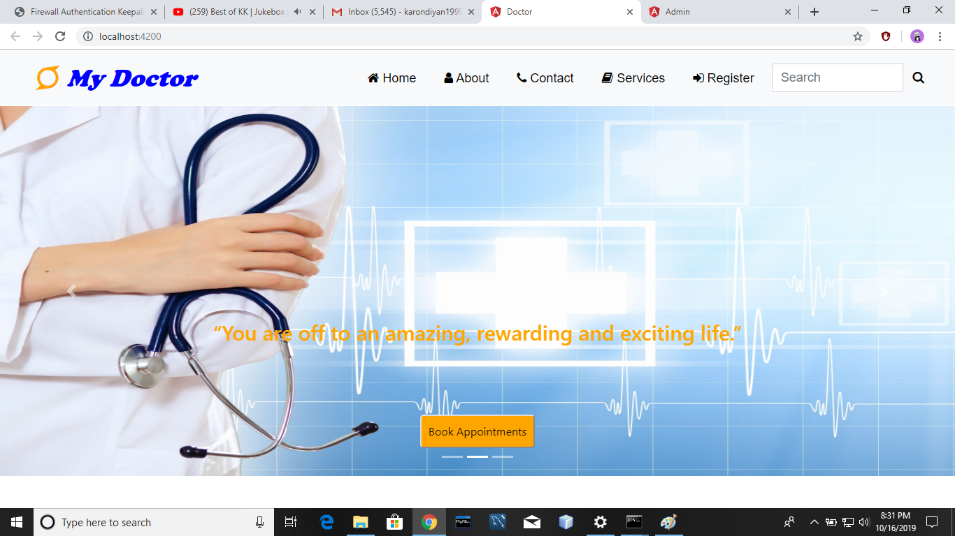

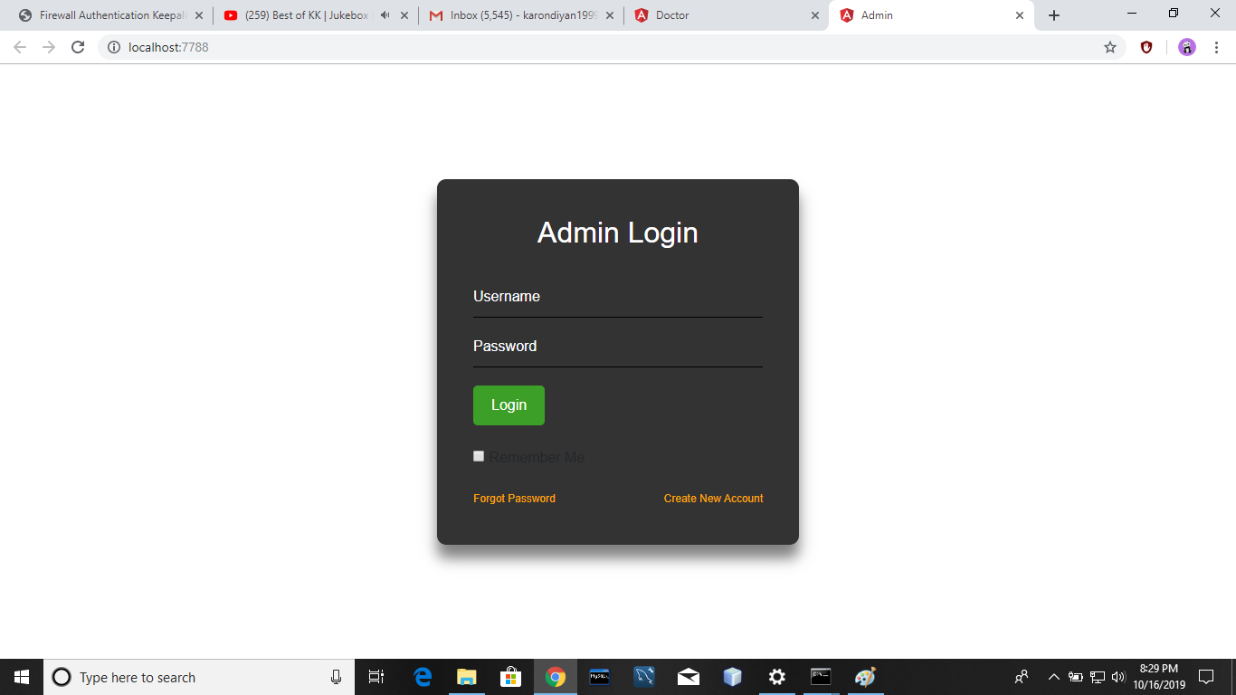

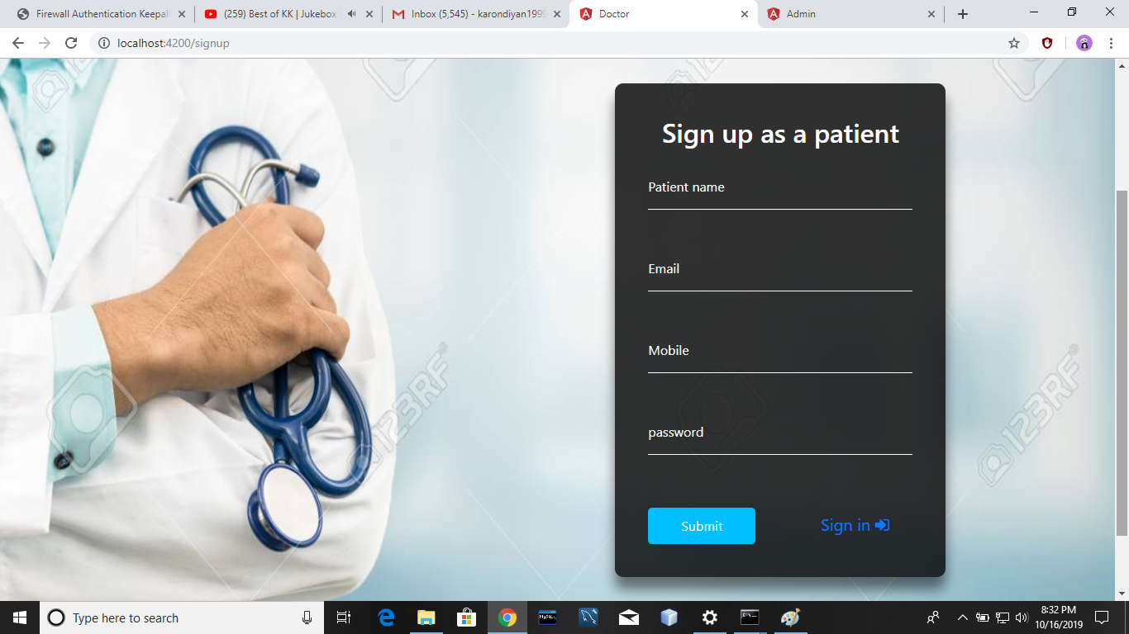

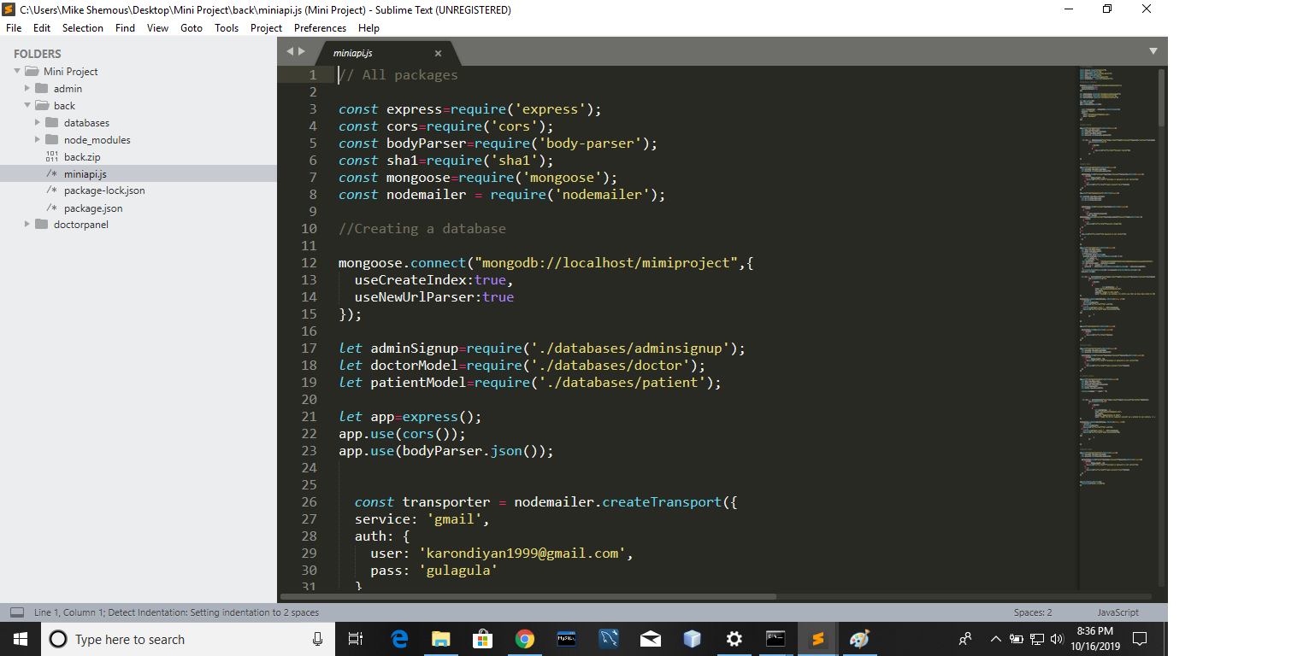

**Contribution summary**

There are three panels in this project. All the three panels will be connected or inter-related to each other. The three panels are as follows:

1.Admin Panel: This panel consist of different components like adminlogin,adminsignup etc which deals with the accessibility of various features by the admin of the website.this panel provides various facilities to the admin to add/remove doctor or patient. Our Group member SUMIT SINGH worked on this model and completed the frontend of this model.

2.Doctor Panel: This panel consist of different components like Doctorlogin,dashboard etc which deals with the accessibility of various features by the Doctors of the website. This panel provides various facilities to the Doctor to edit his/her profile, to accept/decline appointment request .Our Group member SAURABH KUMAR worked on this model and completed the frontend of this model.

3.Patient Panel: This panel consist of different components like Patientlogin,dashboard, etc which deals with the accessibility of various features by the Patient of the website. This panel provides various facilities to the Patient to edit his/her profile, to request for appointment etc . Our Group member YOGESH CHANDWANI worked on this model and completed the frontend of this model.

Backend implementation for all the panel is in progress. Whole group is contributing in its implementation.Bakend is being implemented by discussing with all group members.

**Progress Till Date**

Complete: Frontend development of the project is fully completed for all components. Backend implementation of adminpanel is completed through which admin can add/remove doctors, hospitals or clinics from the database.

Frontend implementation of doctorpanel and patientpanel is complete with backend implantation of login of patient as well as doctor.

Remaining: Backend implementation of doctor editing his/her profile and accept/decline the appointment request

patient applying for appointment by selecting hospital’s name and doctor’s name and editing his/her profile.

**References:**

1. <https://angular.io/>
2. <https://www.w3schools.com/nodejs/nodejs_npm.asp>
3. <https://www.mongodb.com/>